Assignment –4

EXPLORE KUBERNETES/ DOCKER

|  |  |
| --- | --- |
| Assignment Date | 27 October 2022 |
| Student Name | Joshinlisbon N |
| Student Roll Number | 19CS036 |
| Maximum Marks | 2 Marks |

1. Pull an Image from docker hub and run it in docker playground.

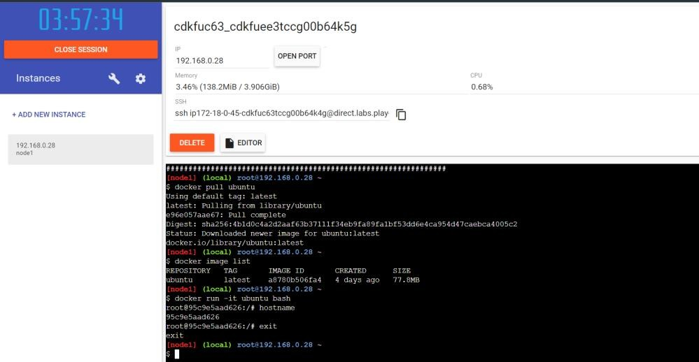

1. Create a docker file for the jobportal application and deploy it in Docker desktop application. Dockerfile

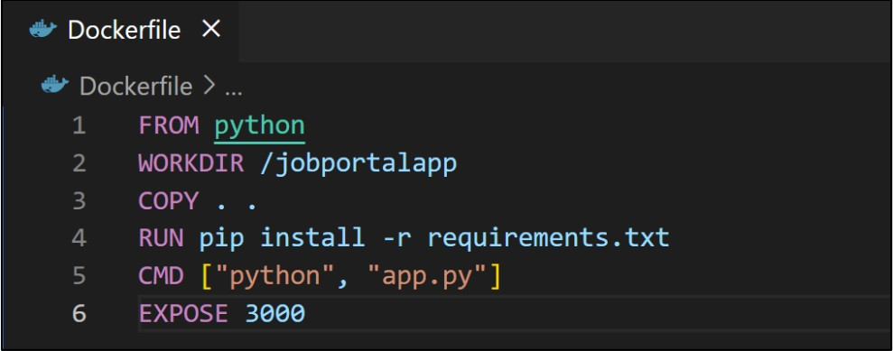

Requirements.txt

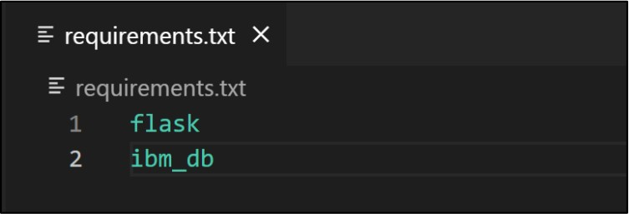

Build image

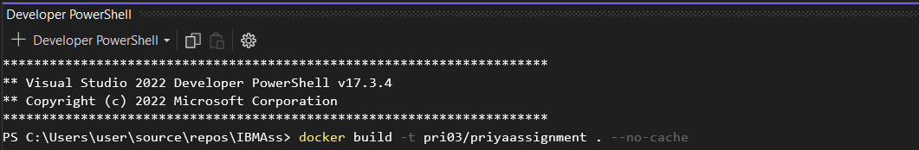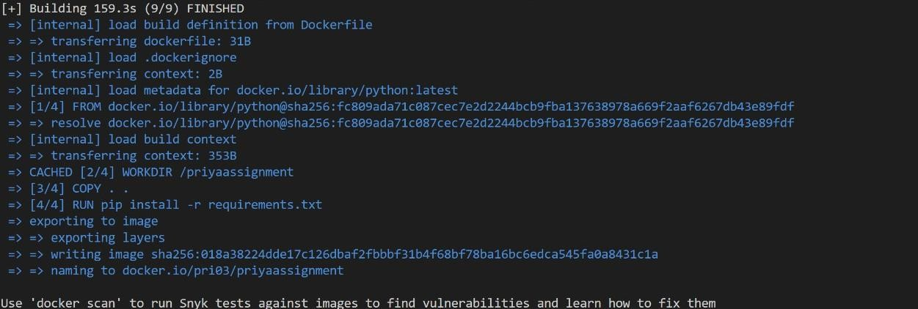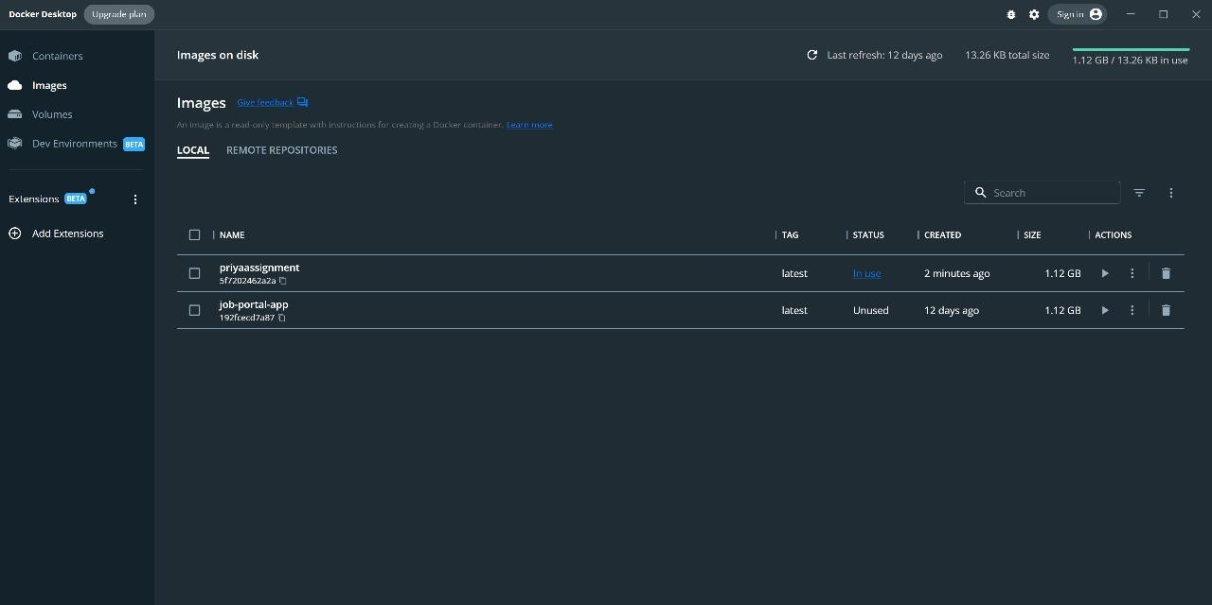

Run Image

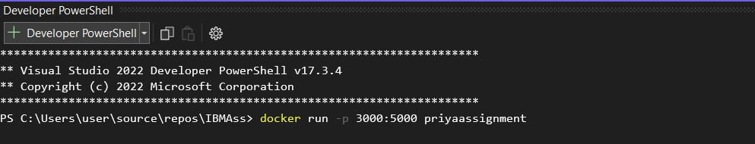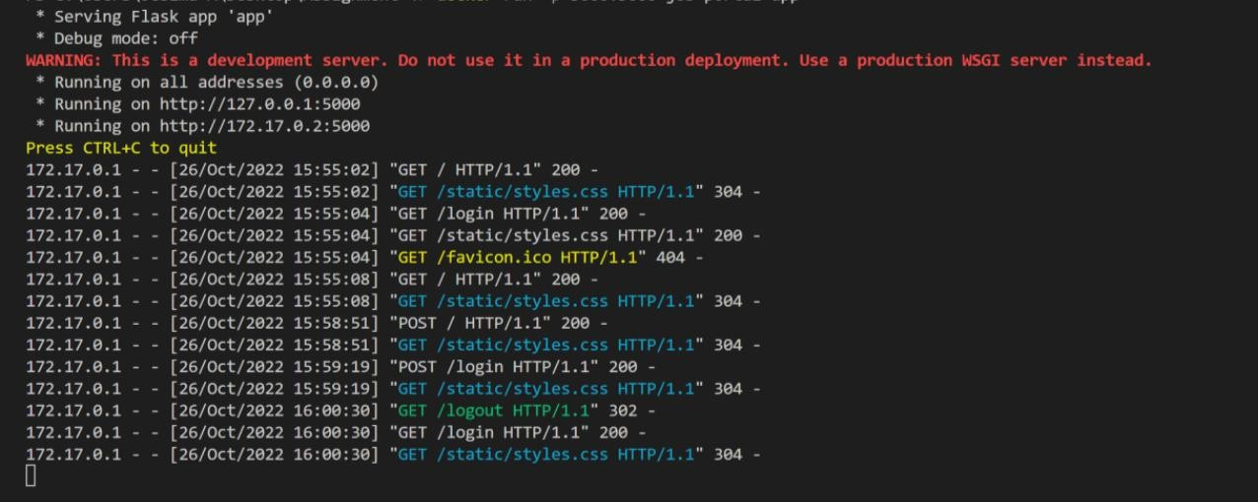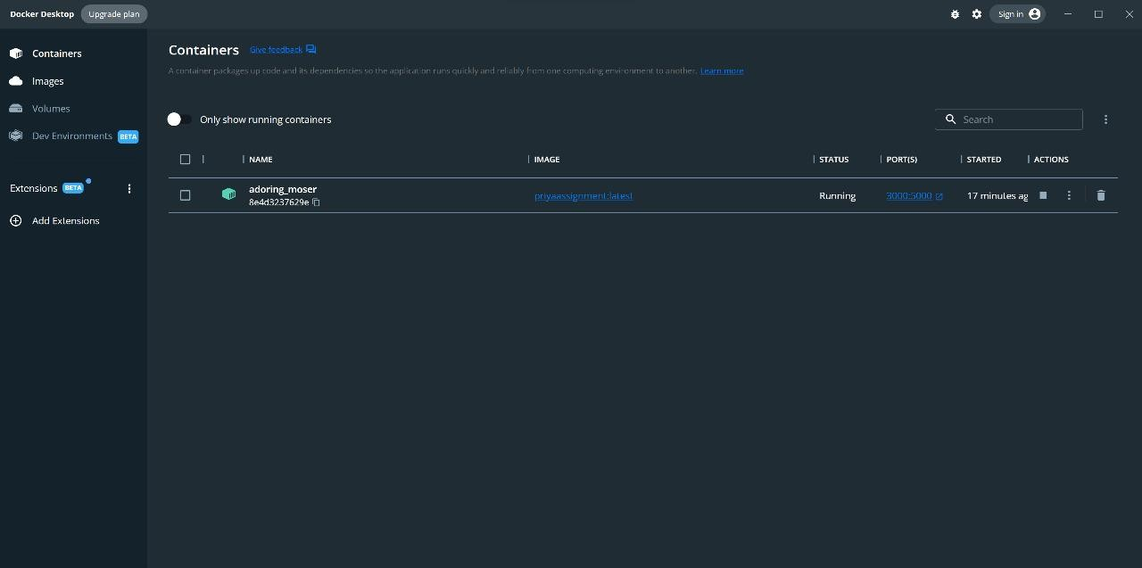

OUTPUT

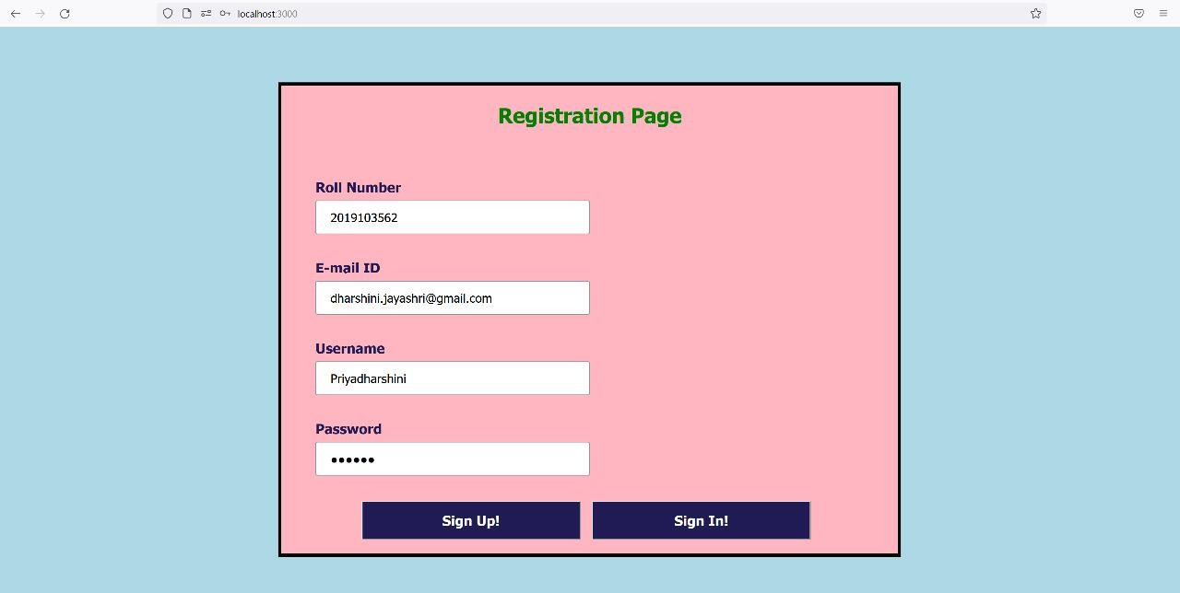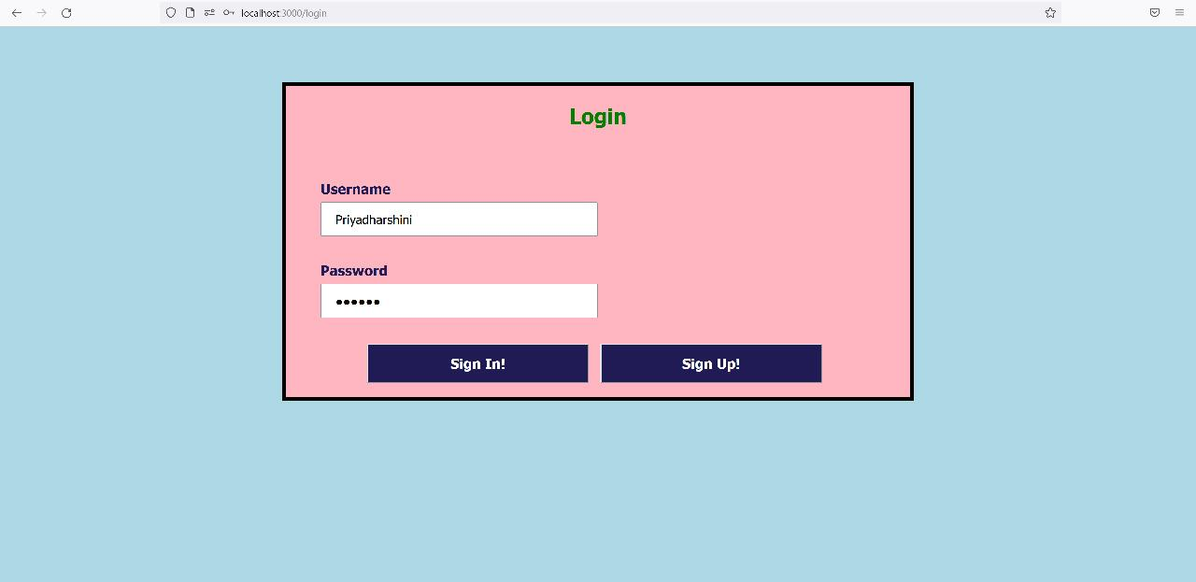

PUSH TO DOCKER HUB

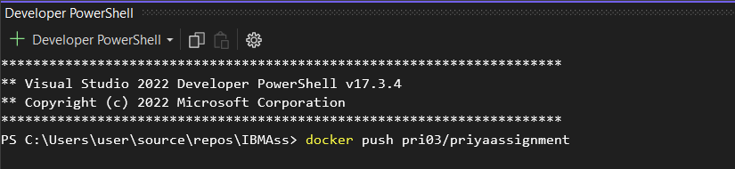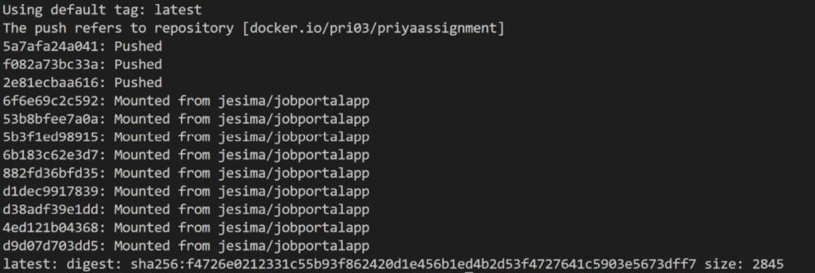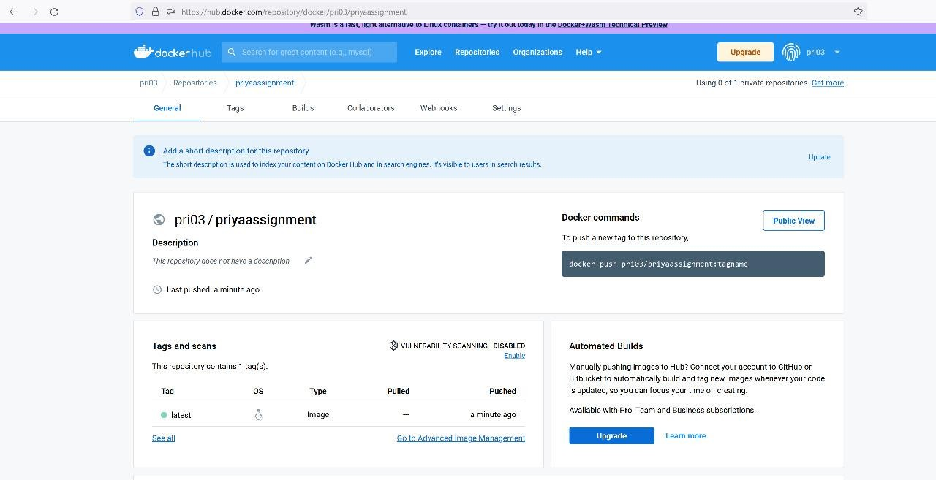

1. Create an IBM container registry and deploy helloworld app or jobportalapp.
   1. Log in to IBM Cloud Account

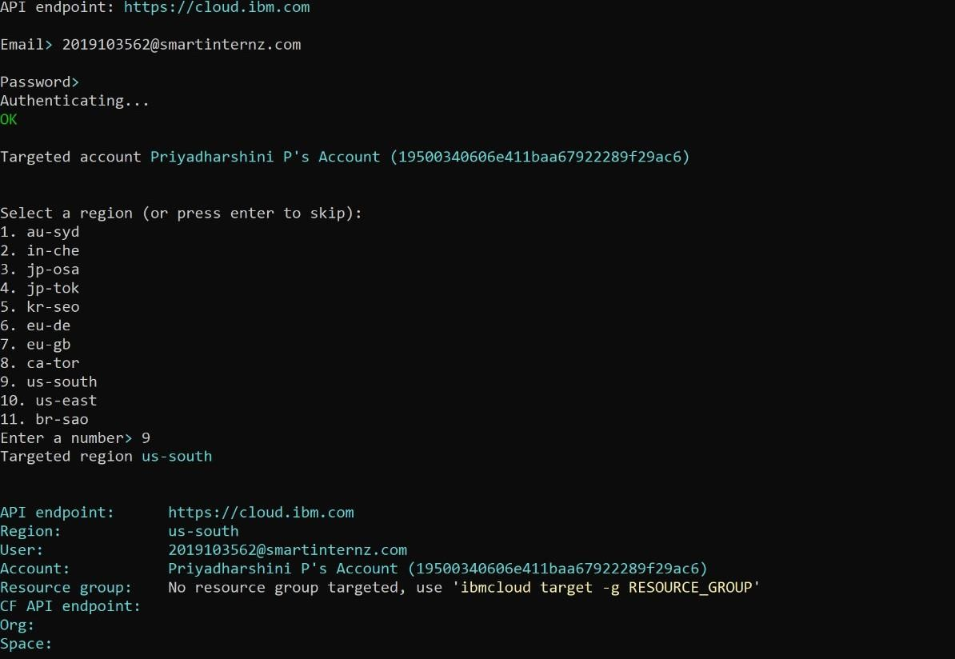

* 1. Set desired region for namespace to be created

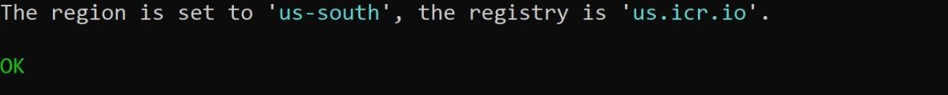

* 1. Create Namespace.

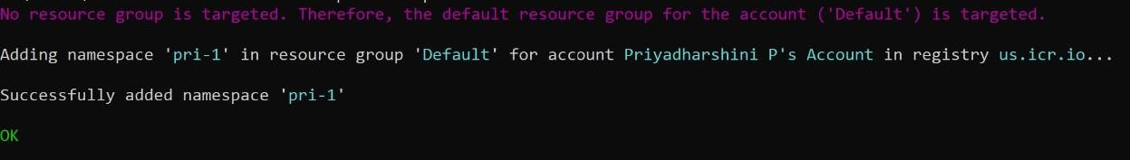

* 1. Log the local Docker daemon into the IBM Cloud Container Registry.

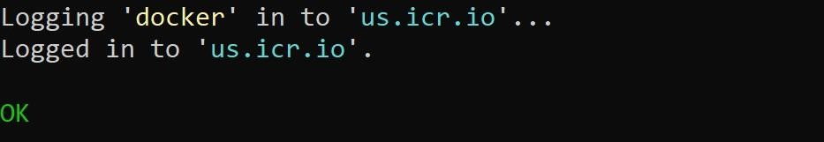

* 1. Give appropriate repository name and tag.



* 1. Push the image

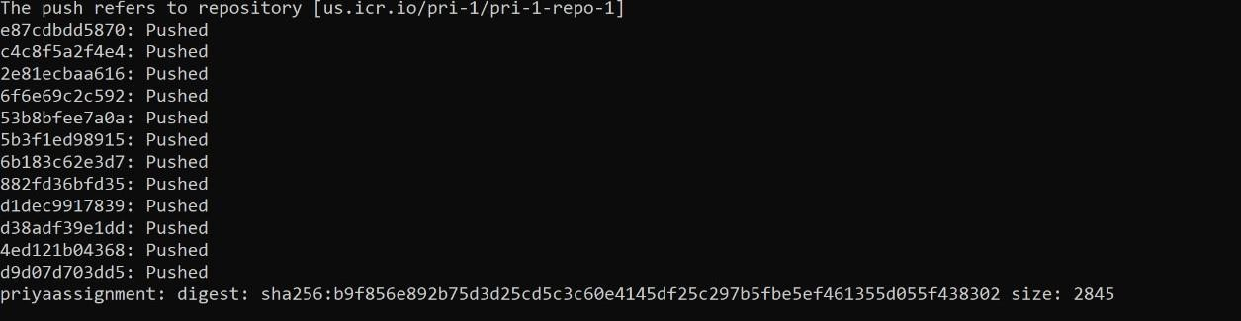

* 1. Verify that the image is in the private registry.



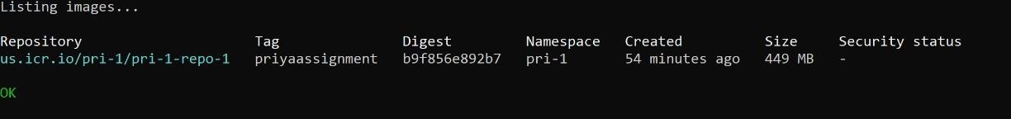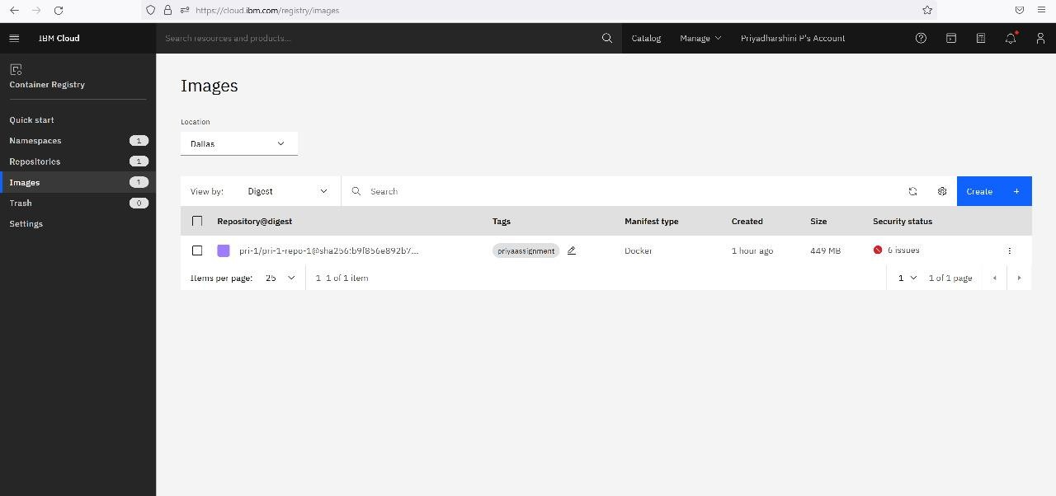

1. Create a Kubernetes cluster in IBM cloud and deploy helloworld image or jobportal image and also expose the same app to run in nodeport

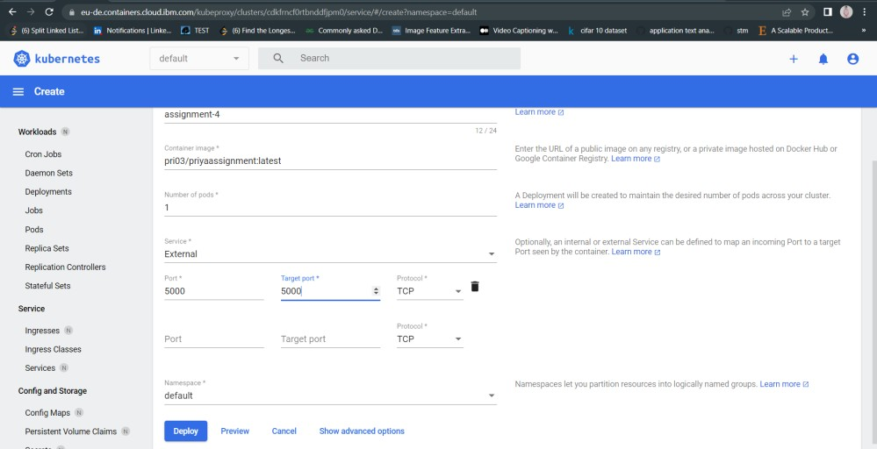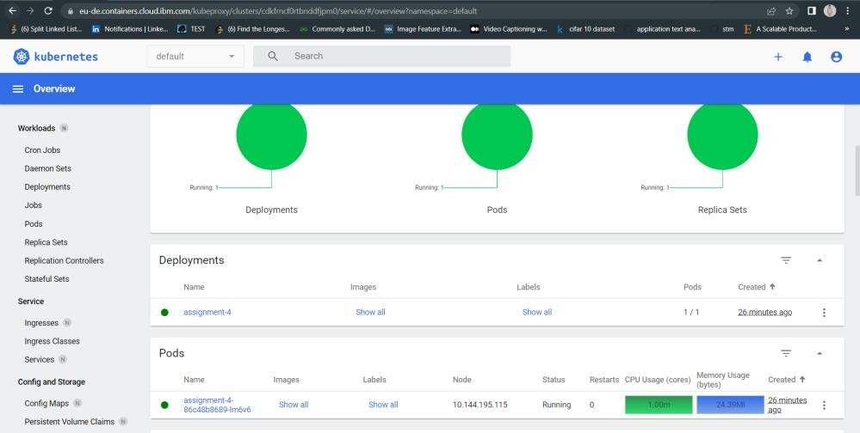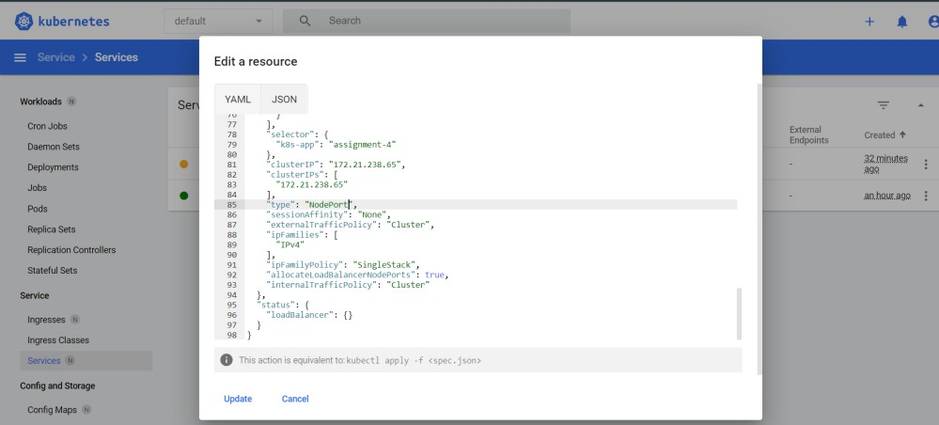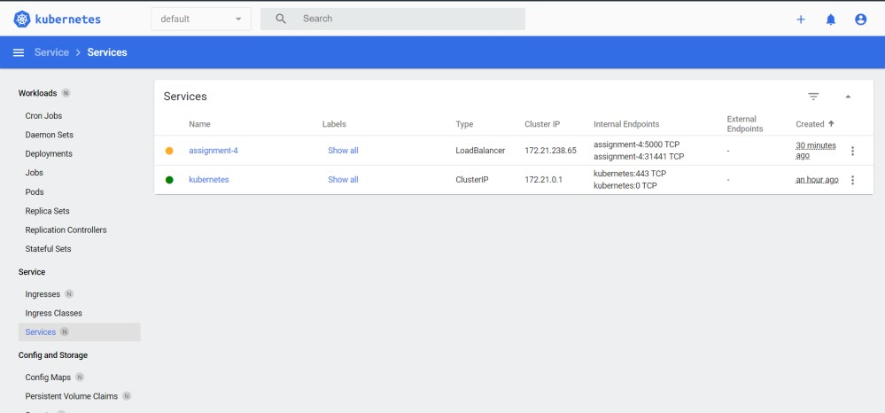

Deployed IP: http://169.51.206.26:31441

